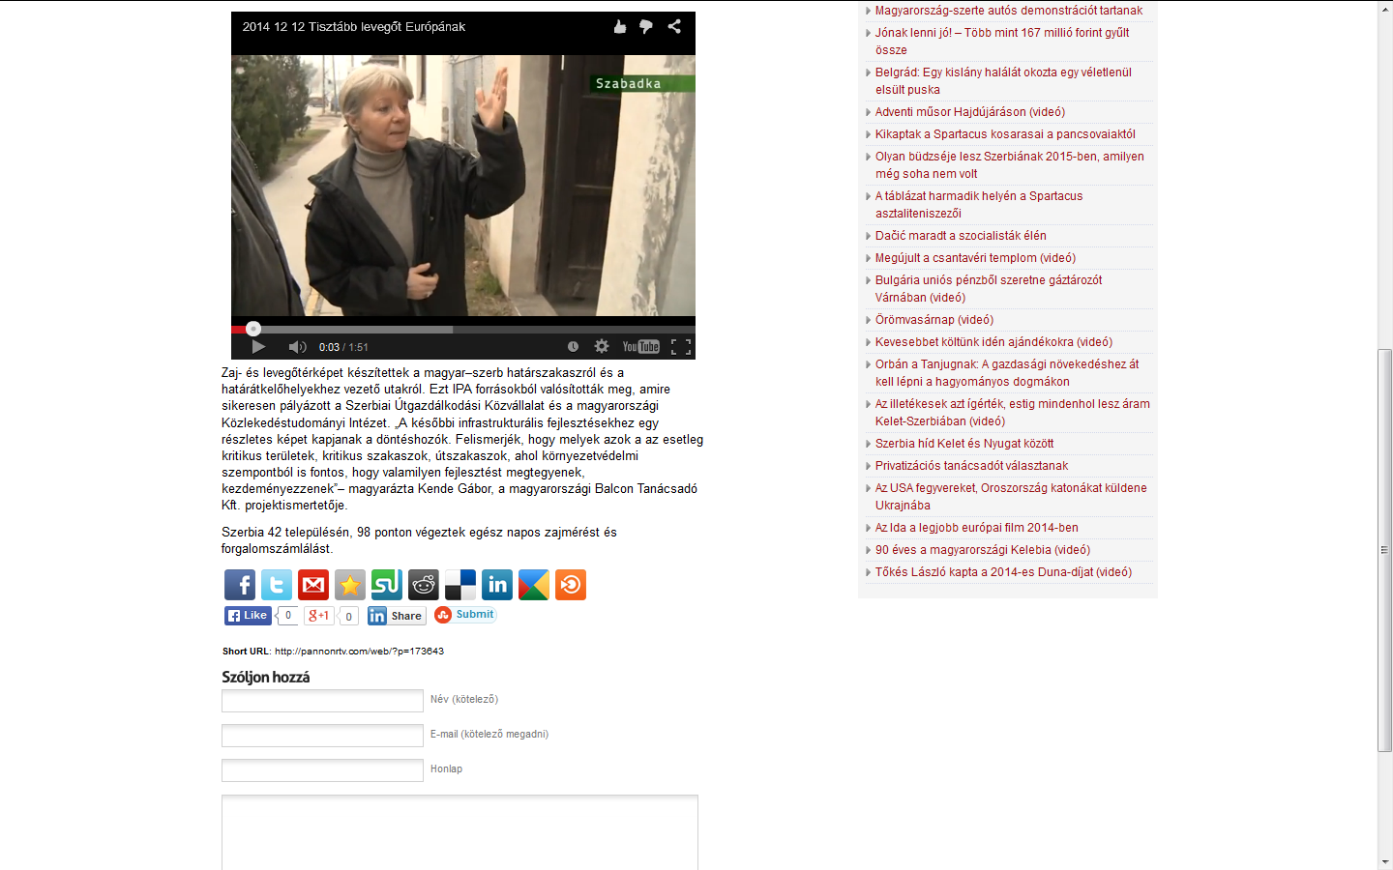

http://pannonrtv.com/web/?p=173643

