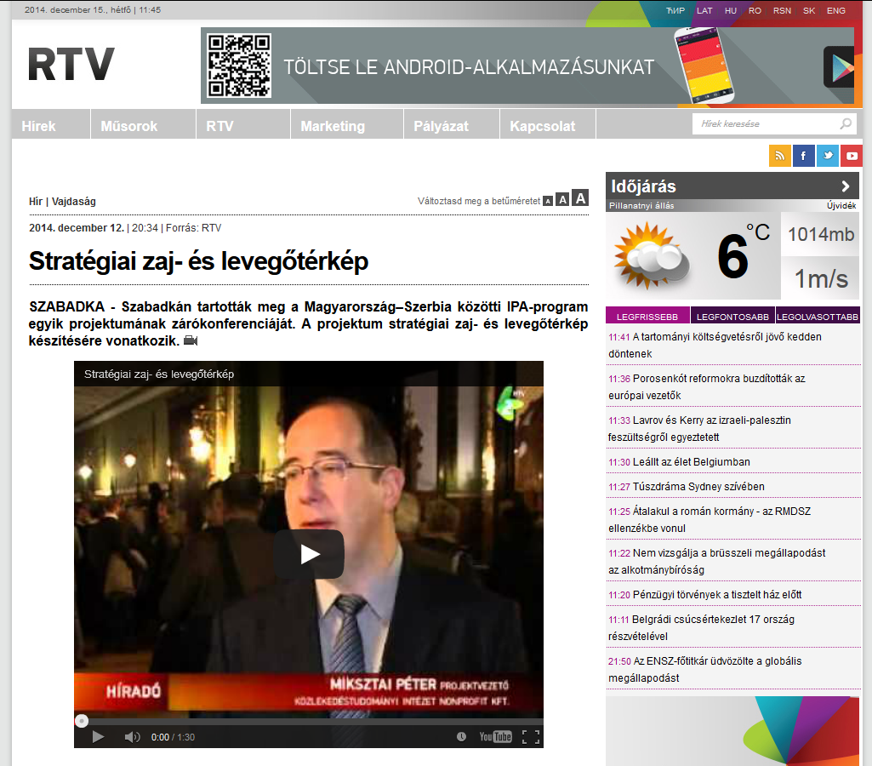

http://www.rtv.rs/hu/vajdas%C3%A1g/strat%C3%A9giai-zaj-%C3%A9s-leveg%C5%91t%C3%A9rk%C3%A9p_547054.html

