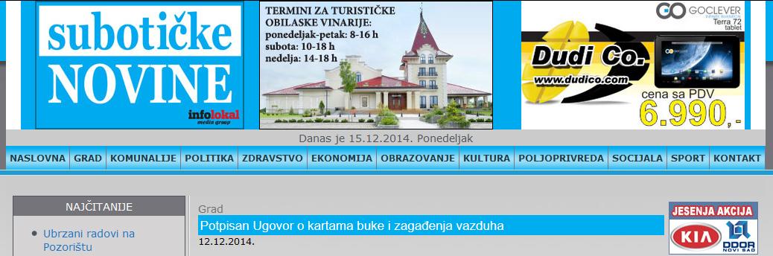
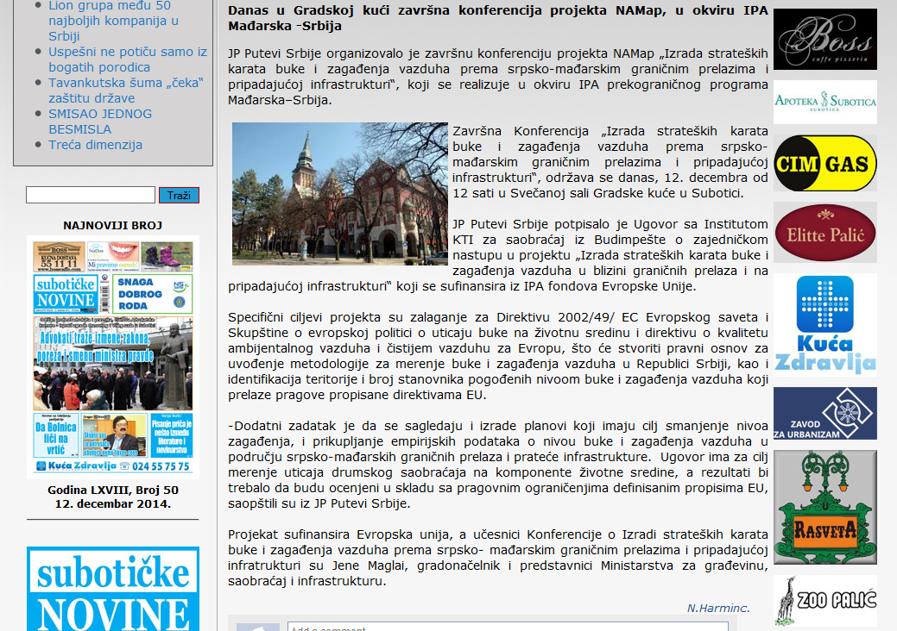

http://www.subotickenovine.rs/index/page/lg/sr/id/1802

